Individual Project Report

Title: Story Management App Using Scrum & Agile Methodology



Abstract

Agile values and principles enable the team to shift their focus and   
  
 change their thought process of building better software.

With the help of this project anyone can register with the app with username and password. After that he/she can create Project and update the project with id.

Under his project he/she can manage his all stories with title and Descriptions.

Registration/Login Page  
In this form New user can Register or Already Existing user can login in the Application.

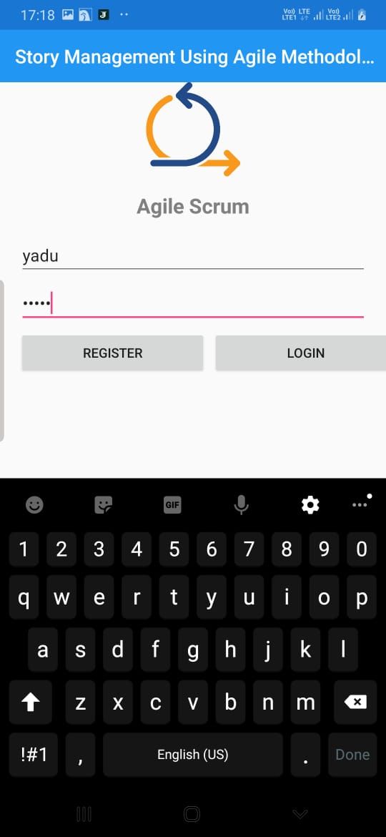

On Registering a Person as New user Message will be shown as below.

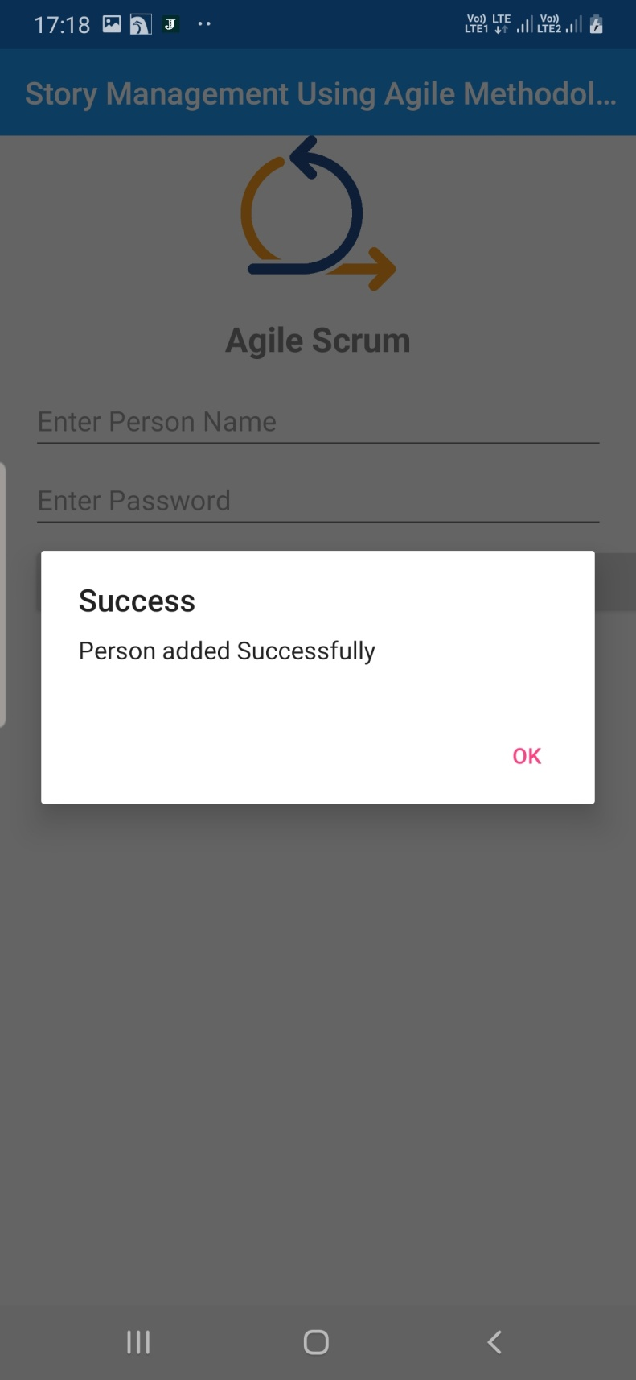

This is the welcome Screen where two option can be seen after login 1. New Project 2. New Story.

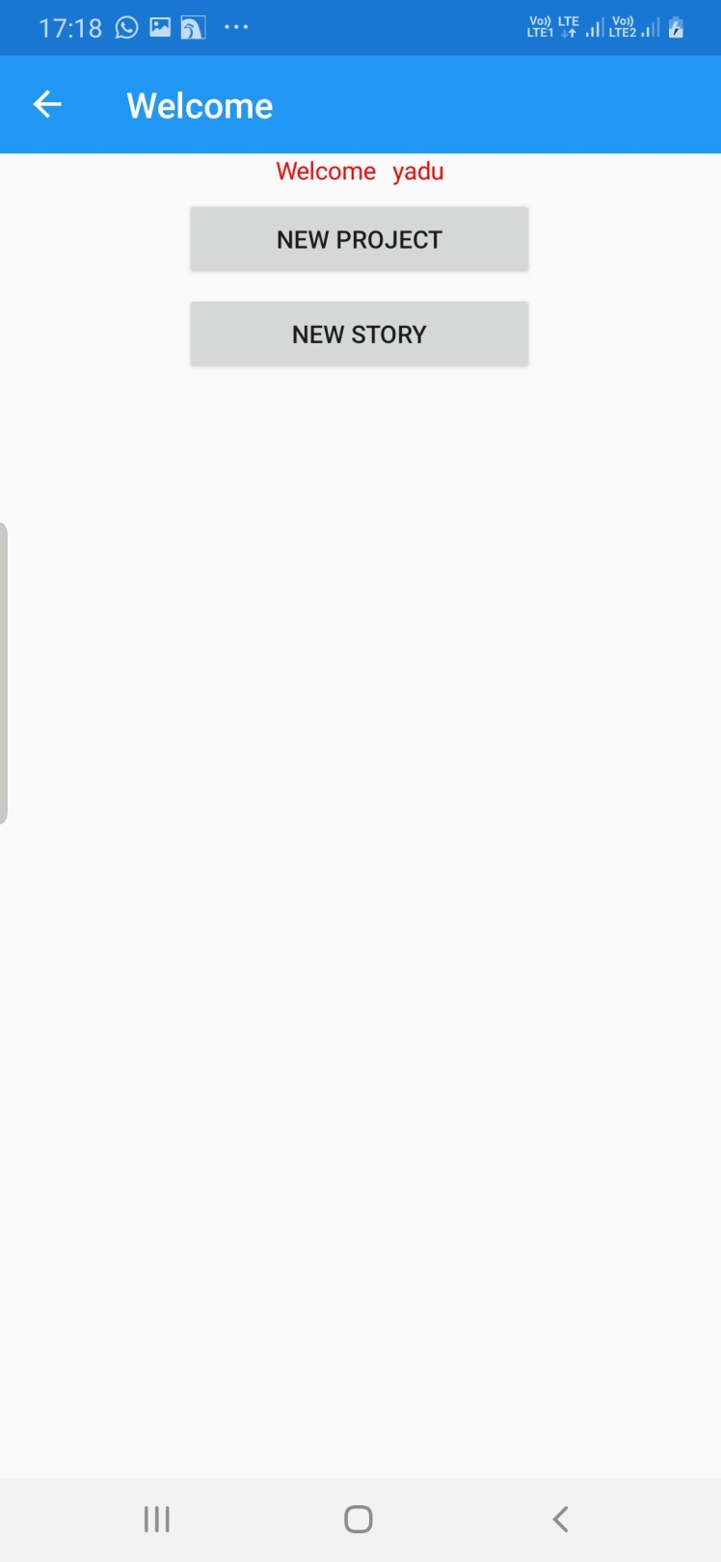

New Project : When login user will click on New project the below form will be shown. In this for login person can create any project of his/her own choice. Project Id will be for updating the record.

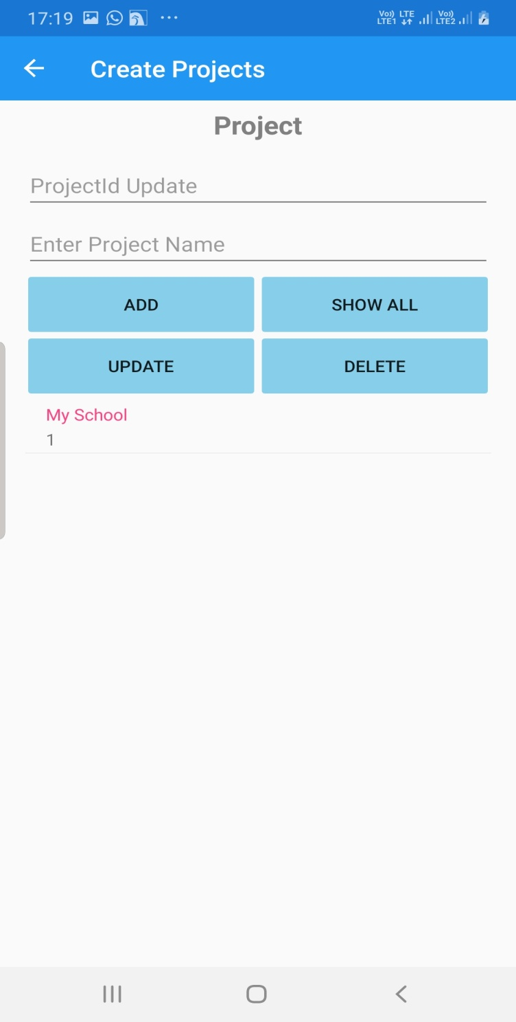

New Story : On clicking New Story on welcome screen, logged in person can write/Update his/her any story under previously created project after the selecting the project.

